The Majorov International Conference on Software Engineering and Computer Systems (MICSECS-2020)

**Instruction of the abstract submission**

**Step 1.** Enter to **Easy Chair** using the link: <https://easychair.org/conferences/?conf=micsecs2020>

**Step 2.** If you **don’t have an account** you have to create it. Please click on the link «**create an account**». If you **have an account,** you have to enter «**User name**» and «**Password**» and press «**Log in**».

**Step 3.** Than choose «**make a new submission**».

**Step 4.** Enter the information about authors and tick «**corresponding author**» in front of the author or authors who will receive the news and notifications about submission.

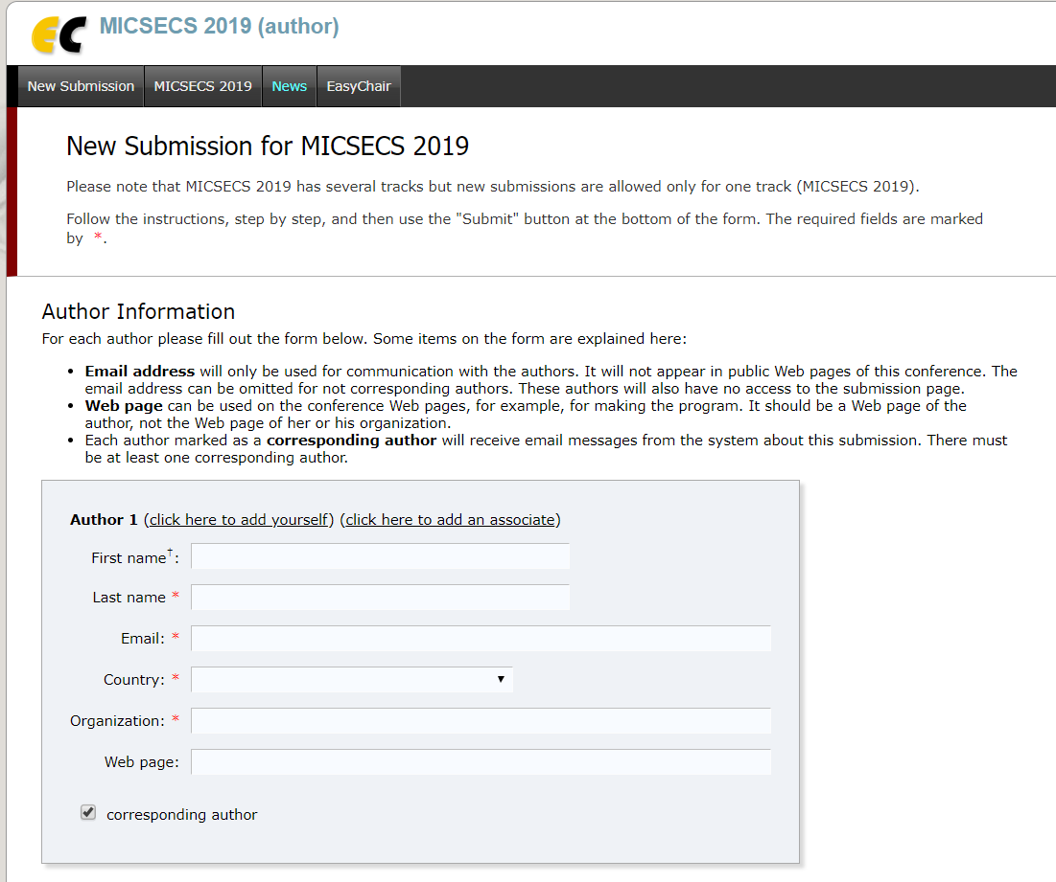

**Step 5.** Enter the title of submission in the field «**Title**». Enter the short description about your work in the field «**Abstract**». The abstract field **will not be reviewed**. It is an information field! The abstract for review you have to attach further in this form. Enter no less three keywords in the field «**Keywords**».

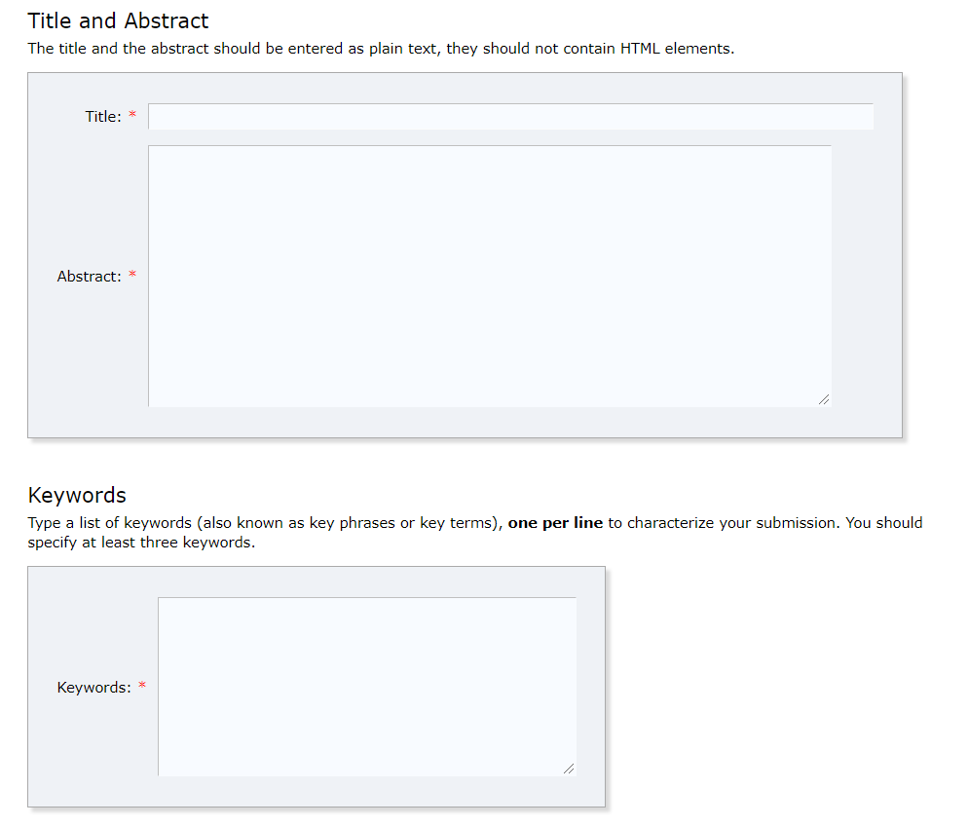

**Step 6.** Attach the abstract for review in the field «**Paper**» as a **single PDF file**.

Your abstract should be prepared using LNCS format (<https://ru.overleaf.com/latex/templates/springer-lecture-notes-in-computer-science/kzwwpvhwnvfj>).

The paper should content **6-12 pages.** The authors should add the type of presentation (**oral presentation** or **poster session**) to the abstract. The type of the presentation should be put after **Keywords** in the abstract.

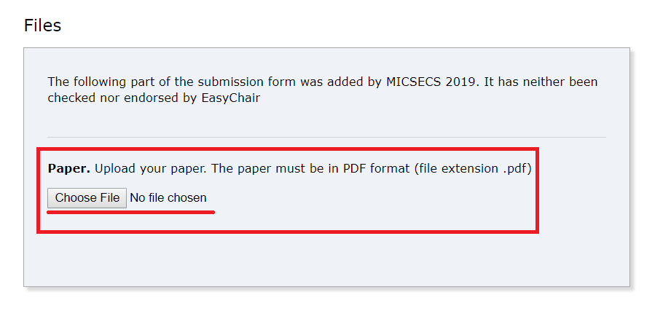

**Step 7.** Check all information in the form and click «**Submit**».

